**Practicle Assignment-1**

**NAME :- DEVAL C. RADADIYA**

**ENROLLMENT No. :- 200802089**

**ROLL No. :- 48**

**DIVISION :- E2**

1. **UDF Function – 3 types**

**\*PROGRAM :-**

<?php

echo "<h1><center>UDF Funnction</center></h1><hr><hr>";

echo "With Arguments<br><br>";

function add($a,$b)

{

$c=$a+$b;

echo "Addition is ".$c."<br><br><hr><hr>";

}

add(30,1);

echo "With Returns<br><br>";

function sub($a,$b)

{

$c=$a-$b;

return $c;

}

$answer=sub(30,1);

echo "Subtraction is ".$answer."<br><br><hr><hr>";

echo "Default Arguments<br><br>";

function mul($x,$y=3)

{

$c=$x*$y;

echo "Multiplication is ".$c."<br><br><hr><hr>";

}

mul(30,);

echo "Combine UDF<br><br>";

function div($x,$y=2)

{

$z=$x/$y;

return $z;

}

$answer=div(30,);

echo "Division is ".$answer."<hr><hr>";

?>

* **OUTPUT :-**

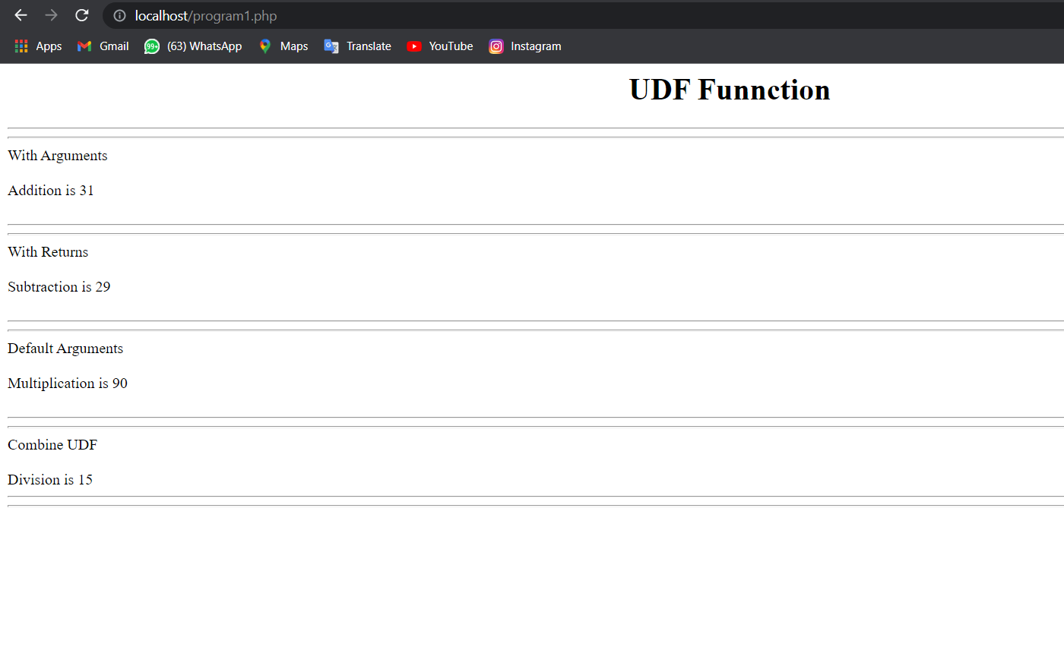

**2 LOGIN Form – 2ways - Using $_get & $_post**

**\* PROGRAM :**

**1 - Program using $_get :-**

<?php

echo "<center>

<form method='GET'>

<table border='5px' heigth='50%' width='50%' height='50%' align='center'><tr><td>

<table heigth='50%' width='100%' align='center'>

<center><strong>LOGIN PAGE</strong></center><br>

<tr>

<th>User Name : </th>

<th><input type='text' name='unm'></th>

</tr>

<tr>

<th>Password : </th>

<th><input type='password' name='pswd'></th>

</tr>

<tr>

<th>

<th><align='center'><input type='submit' name='s'>

</table>

</table>

</center>";

if(isset($_GET['s']))

{

$a=$_GET['unm'];

$b=$_GET['pswd'];

echo "User Name : ".$a."<br>";

echo "Password : ".$b;

}

?>

* **OUTPUT:-**

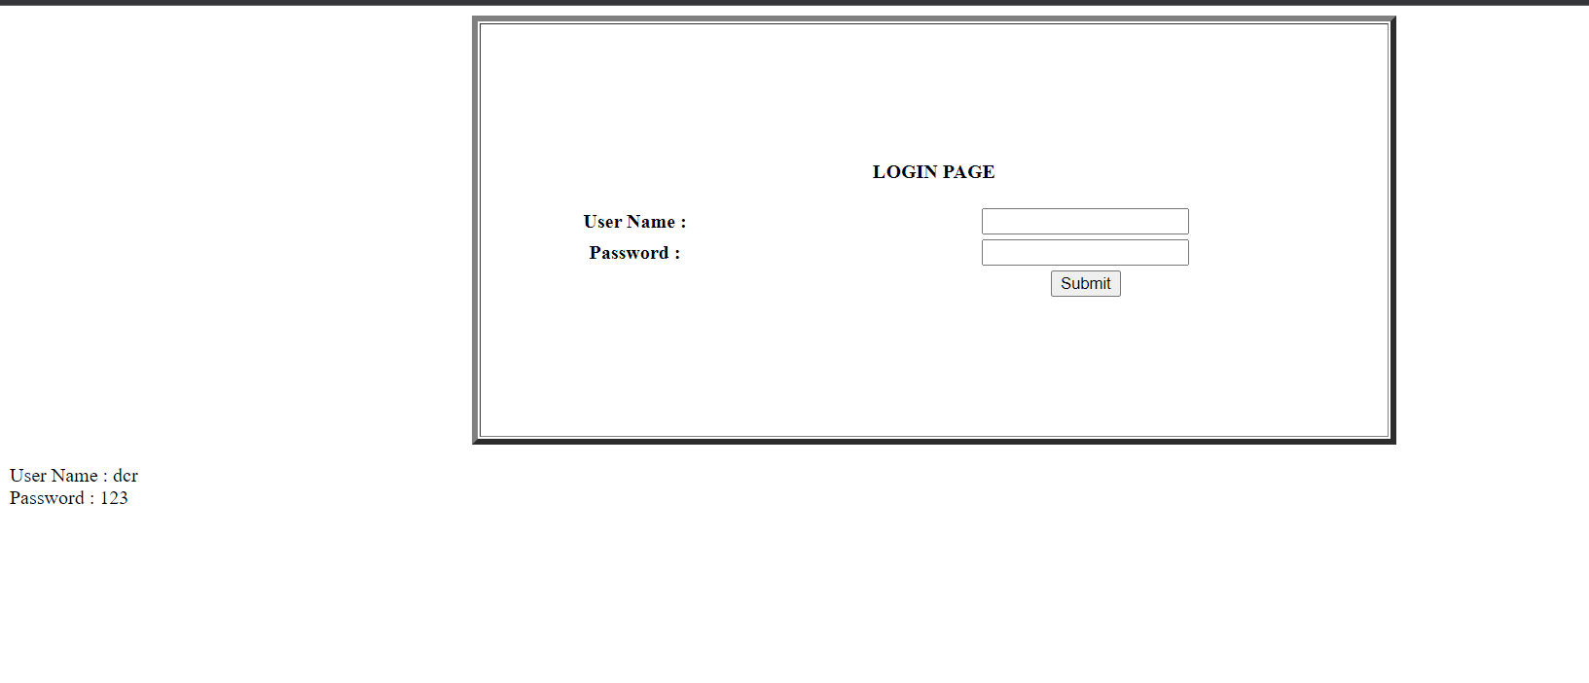

**2 - Program using $_post :-**

<?php

echo "<center>

<form method='POST'>

<table border='5px' heigth='50%' width='50%' height='50%' align='center'><tr><td>

<table heith='50%' width='100%' align='center'>

<center><strong>LOGIN PAGE</strong></center><br>

<tr>

<th>User Name : </th>

<th><input type='text' name='unm'></th>

</tr>

<tr>

<th>Password : </th>

<th><input type='password' name='pswd'></th>

</tr>

<tr>

<th>

<th><align='center'><input type='submit' name='s'>

</table>

</table>

</center>";

if(isset($_GET['s']))

{

$a=$_POST['unm'];

$b=$_POST['pswd'];

echo "User Name : ".$a."<br>";

echo "Password : ".$b;

}

?>

* **OUTPUT :-**



**3) ARRAY – 4 Types Of Array – Using Check Box :-**

**\* Program :-**

<?php

echo "<h2><center>ARRAY TYEPS</center></h2>";

echo "<form method='POST'>

<b>AUTOMATIC Array :<input type='checkbox' name='z1' value='a'><br>

MANUALLY Array :<input type='checkbox' name='z2' value='m'><br>

ASSOCIATIVE Array :<input type='checkbox' name='z3' value='as'><br>

TWO - Dimentional Array :<input type='checkbox' name='z4'

value='mu'><br><br>

<input type='submit' name='save' value='SUBMIT'></b>

</form>";

if(isset ($_POST['save']))

{

$x=isset($_POST['z1']);

$x1=isset($_POST['z2']);

$x2=isset($_POST['z3']);

$x3=isset($_POST['z4']);

if($x=='a')

{

echo "You Selected <b>AUTOMATIC Array .......... </b><br>";

echo "<br>";

$y=array(100,200,300,400,500,600,700,800,900,1000);

for($i=0 ; $i<=2 ;$i++)

{

echo $y[$i]." ";

}

echo "<hr>";

}

if($x1=='m')

{

echo "<hr>";

echo "You Selected <b>MANUALLY Array ......... </b><br>";

echo "<br>";

$y=array(100=>'PHP',200=>'JAVA',300=>'SAD');

foreach ($y as $z)

{

echo $z." ";

}

echo "<hr>";

}

if($x2=='as')

{

echo "<hr>";

echo "You Selected <b>ASSOCIATIVE Array ......... </b> <br>";

$y=array('PHP'=>100,'JAVA'=>200,'SAD'=>300);

foreach ($y as $z=>$c)

{

echo "<br>".$z." SUBJECT Marks :- ".$c;

}

echo "<hr>";

}

if($x3=='mu')

{

echo "<hr>";

echo "You Selected <b>MULTI-Dimentional Array..........</b><br>";

$marks=array('Pratik'=>array('PHP'=>90,'JAVA'=>95,'SAD'=>87),

'Kashyap'=>array('PHP'=>95,'JAVA'=>90,'SAD'=>78));

foreach($marks as $k1=>$v1)

{

echo "<br>".$k1."<br>";

foreach($v1 as $k2=>$v2)

{

echo $k2."MARKS = ".$v2."<br>";

}

}

echo "<hr>";

}

}

?>

* OUTPUT :-

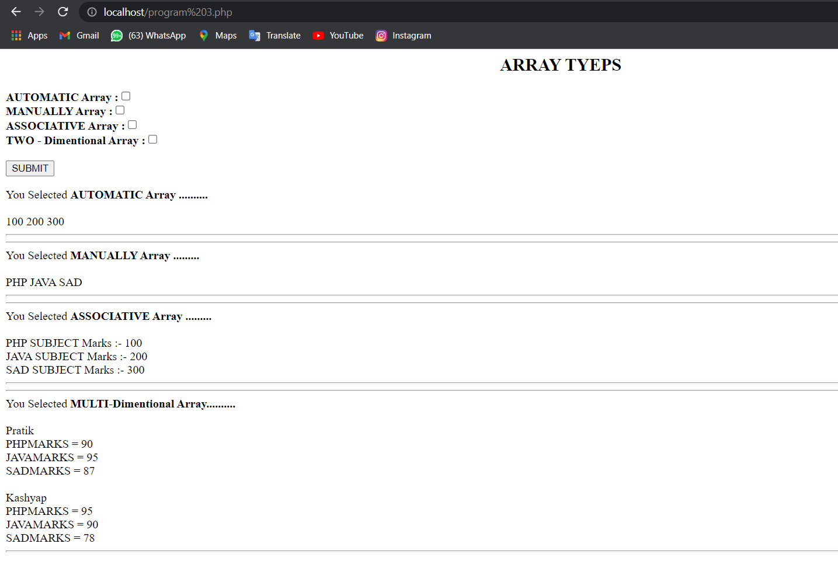

**4) STRING Function – Using Radio Button**

**\*Program :-**

<?php

echo "<h2><center>STRING FUNCTION</center></h2>";

echo "<form method='POST'><b>

1.CHR : <input type='radio' name='d1' value='a'><br>

2.ORD : <input type='radio' name='d1' value='b'><br>

3.STRTOLOWER : <input type='radio' name='d1' value='c'><br>

4.STRTOUPPER : <input type='radio' name='d1' value='d'><br>

5.STRREV : <input type='radio' name='d1' value='e'><br>

6.STRLEN : <input type='radio' name='d1' value='f'><br>

7.LTRIM : <input type='radio' name='d1' value='g'><br>

8.RTRIM : <input type='radio' name='d1' value='h'><br>

9.TRIM : <input type='radio' name='d1' value='i'><br>

10.SUBSTR : <input type='radio' name='d1' value='j'><br></b>";

echo "<br><input type='submit' name='save'></form>";

if(isset($_POST['save']))

{

if(isset($_POST['d1']))

{

if(($_POST['d1'])=='a')

{

echo chr(101);

}

elseif(($_POST['d1'])=='b')

{

echo ord("D");

}

elseif(($_POST['d1'])=='c')

{

echo strtolower("DEVAL RADADIYA");

}

elseif(($_POST['d1'])=='d')

{

echo strtoupper("deval radadiya");

}

elseif(($_POST['d1'])=='e')

{

echo strrev("ATMIYA");

}

elseif(($_POST['d1'])=='f')

{

echo strlen("deval radadiya");

}

elseif(($_POST['d1'])=='g')

{

echo ltrim(" PRATIK CHUDASMA");

}

elseif(($_POST['d1'])=='h')

{

echo rtrim("KASHYAP DUDHAGRA ");

}

elseif(($_POST['d1'])=='i')

{

echo trim(" DEVAL RADADIYA ");

}

elseif(($_POST['d1'])=='j')

{

echo substr("DEVAL RADADIYA",3);

}

else

{

echo " ";

}

}

}

?>

**\*OUTPUT :-**

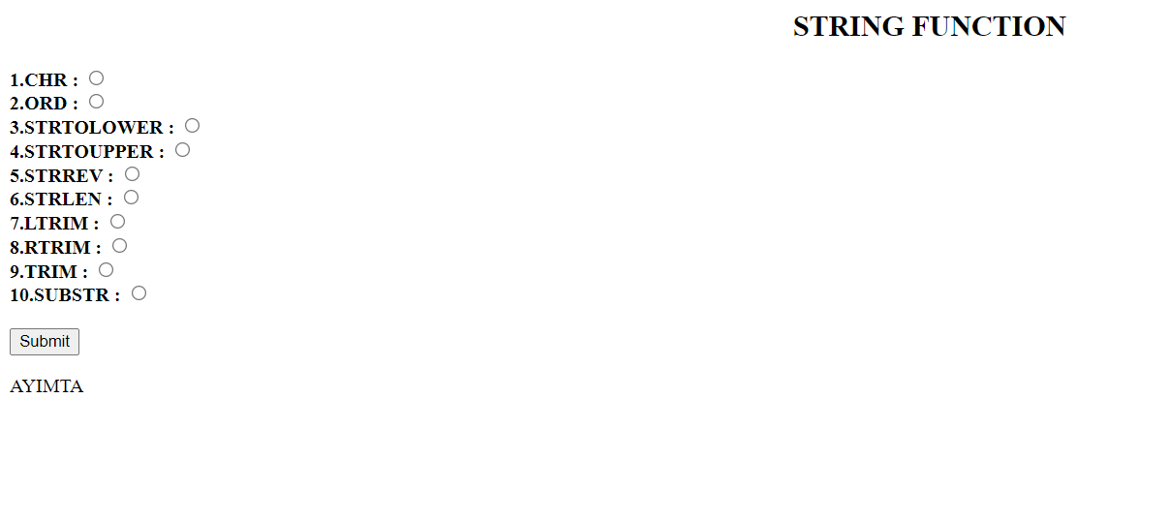

**5) MATH Function :-**

**\*Program :-**

<?php

echo "<center><h1>ANSWER<br><br>";

if(isset($_POST['save']))

{

if(!empty($_POST['Math']))

{

$x=$_POST['Math'];

switch($x)

{

case 1:

echo "<br>abs(-10) = ".abs(10);

break;

case 2:

echo "<br>ceil(10.5)=".ceil(10.5);

break;

case 3:

echo "<br>floor(10.7)=".floor(10.7);

break;

case 4:

echo "<br>fmod(10,5)=".fmod(10,7);

break;

case 5:

echo "<br>min(10,9,8,7,-4-7-9-2,6)".min(10,9,8,7,-4-7-9-2,6);

break;

case 6:

echo "<br>max(10,9,8,7,-4-7-9-2,6)".max(10,9,8,7,-4-7-9-2,6);

break;

case 7:

echo "<br>pow(10,2)=".pow(10,2);

break;

case 8:

echo "<br>sqrt(1000)=".sqrt(1000);

break;

case 9:

echo "<br>rand(15,20)=".rand(15,20);

break;

case 10;

echo "<br>round(677.62)=".round(677.62);

break;

default:

echo "Invalid Choice..!! Please Try Again..!!";

}

}

else

{

echo "Please Select";

}

echo "<h1></center>";

}

?>

**\*OUTPUT :-**

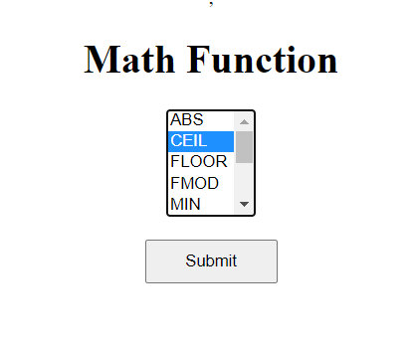

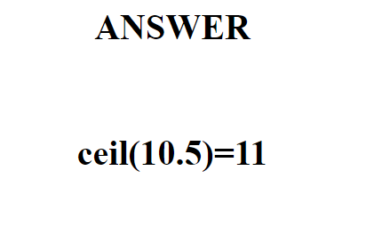

**6) DATE Function:-**

**\*Program :-**

<?php

echo "<center>";

echo "<form method='post'>

<b><font size='5' color='blue'>Date

Function :</font></b><br><br>

<select name='d_fun'>

<option value='a'>GetDate Function</option>

<option value='b'>Check Date Function</option>

<option value='c'>Date Create Function</option>

<option value='d'>Time Function</option>

<option value='e'>Local Time Function</option>

</select>

<br><br>

<input type='submit' name='s' value='Submit'>

</form>";

if(isset($_POST['s']))

{

if(isset($_POST['d_fun']))

$ch=$_POST['d_fun'];

switch ($ch)

{

case 'a':

echo "<b>Date Function :-</b><br><br>";

$a=getdate();

print_r($a);

break;

case 'b':

echo "<b>Check Date Function :-</b><br><br>";

if(checkdate(8, 15, 22))

{

echo "You Enter Valid Date(8/15/2022)";

}

else

{

echo "You enter Invalid Date !!!";

}

break;

case 'c':

echo "<b>Date Create Function :-</b><br><br>";

$date=date_create("2017-11-12");

echo date_format($date,"d/F/Y");

break;

case 'd':

echo "<b>Time Function :-</b><br><br>";

$t=time();

echo "Show Current Date And Time : ".date("d/F/Y H:i:s",$t);

break;

case 'e':

echo "<b>Local Time Function :-</b><br><br>";

$t=localtime(time(),true);

foreach ($t as $key=>$val)

{

echo "$key => $val <br>";

}

break;

default:

echo "Invalid !!!";

}

}

else

{

echo "Please Select....!!";

}

echo "</center>";

?>

**\*OUTPUT:-**

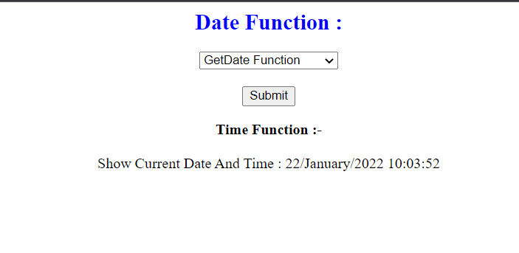

**8) MISCELLANEOUS FUNCTION :-**

**\*Program :-**

<?php

echo "<h2><center>MISCELL FUNCTION</center></h2>";

//Define and Constant Function

echo "<b>Define and Constant Functions...</b><br>";

define('color','blue');

echo "<br>Color is ".constant('color')."<br><br><br>";

//Include and Required Function Function

echo "<b>include and Require Function....</b><br>";

for($i=1;$i<=10;$i++)

{

echo "$i<br>";

if($i=='5')

{

include('miscell_function.php');

}

}

// Header Function......

echo "<b><br><br><br>Header Function......</b><br>";

echo "<br>Here Control Of script is move to New Page With

The Help Of <b>Header()</b><br><br>";

echo "<form method='POST'> <input type='submit'

name='save' value='Move to New Page'></form>";

if(isset($_POST['save']))

{

header('location:miscell_function.php');

}

?>

* MISCELL Function :-

<?php

//Die or exit Functions....

echo "<br><br><b>Die or exit Functions... </b><br><br>";

for($i=1;$i<=10;$i++)

{

echo "$i<br>";

if($i=='5')

{

exit("Loop Is Terminate By exit() ...");

echo "<br><br>";

}

}

?>

**\*OUTPUT :-**

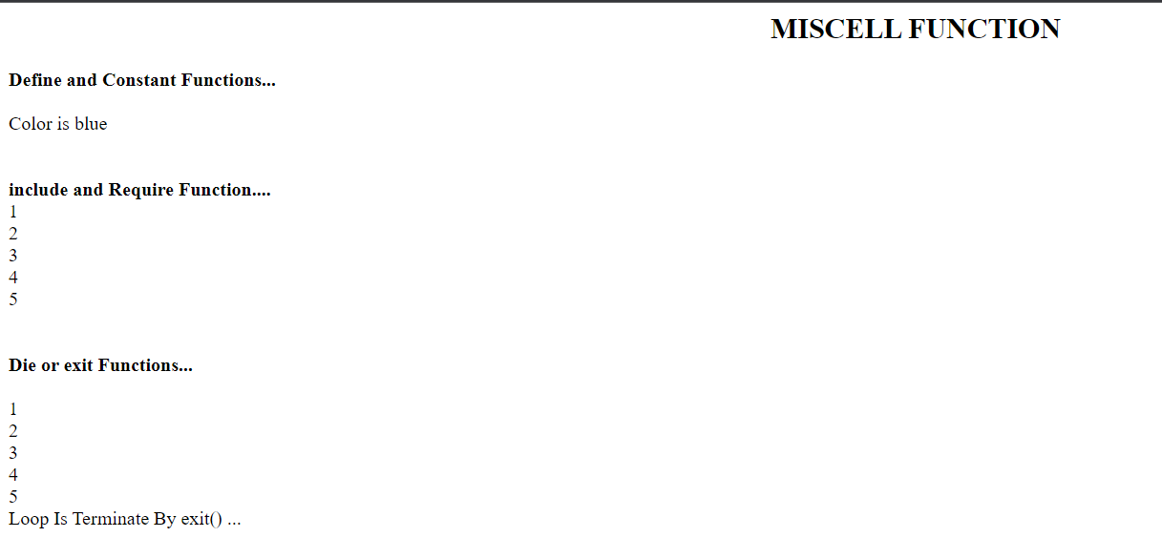

**9) VARIABLE_LENGH_ARGUMENT_FUNCTION – IF—ESLEIF :-**

**\*Program :-**

<?php

echo "<center><h2><b>";

function abc()

{

$a=func_num_args();

$b=func_get_args();

foreach($b as $n)

{

echo $n."<br>";

}

}

abc(100,200,300,'xyz',12.56,true);

echo "</b></h2></center>";

?>

**\*OUTPUT:-**

